1. Helm Chart Architecture?
2. Helm Chart CLI ?
3. First **“Hello World ”** Helm Chart

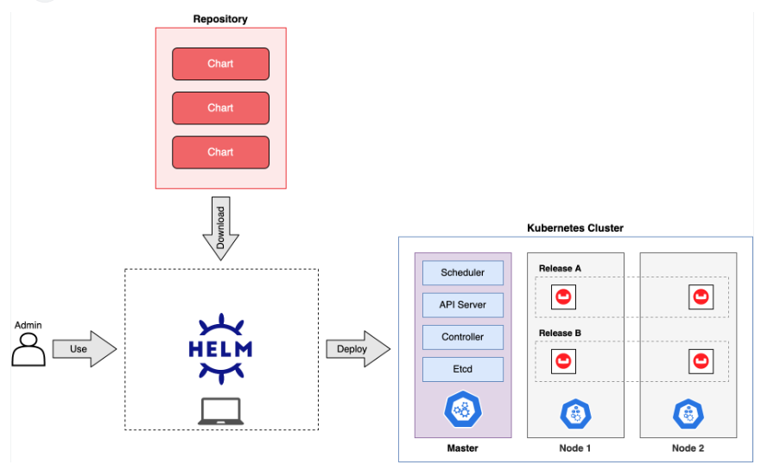

helm create helloworld

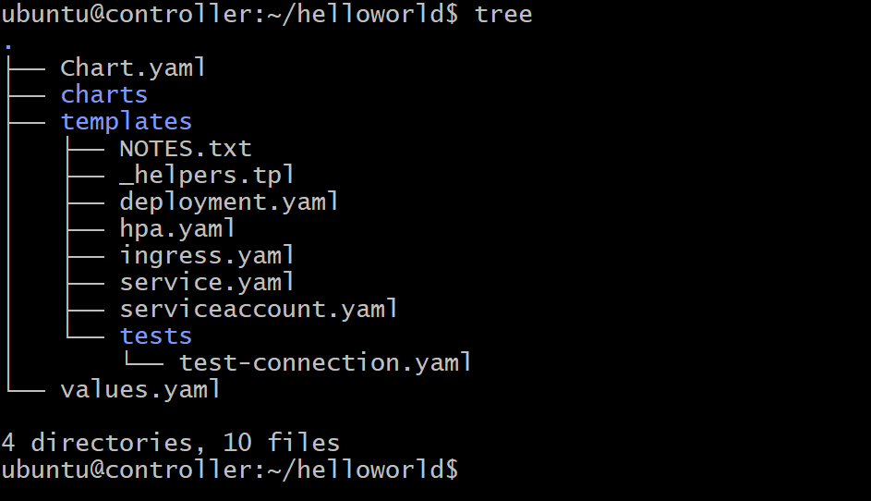

Vi values.yaml

**Change**

service.type = NodePort

replicaCount=2

helm install myhello-deployment helloworld

Or

microk8s helm3 install myhello-deploy helloworld/

microk8s dashboard-proxy

change http to https

if ur using ec2 instance ubuntu

https:// 54.174.150.156:10443

**Login token**

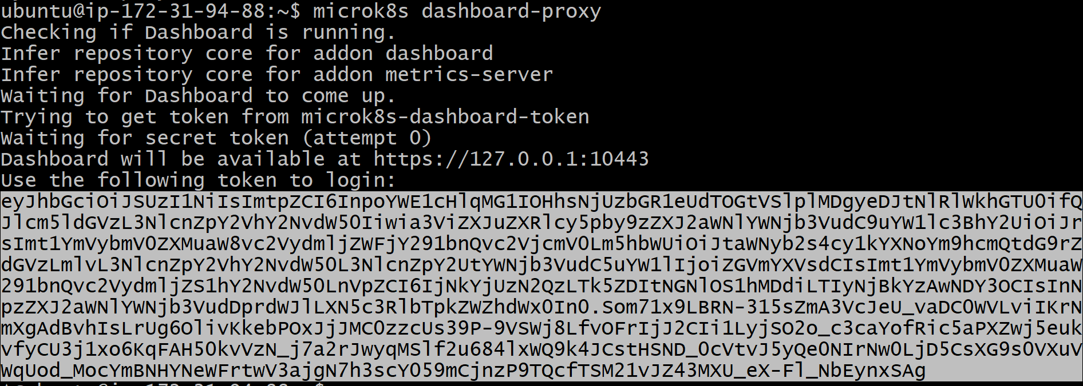

Use this token when browser prompt and asks for key

**UNINSTALL:**

microk8s helm3 uninstall myhello-deploy --namespace default

0r

helm uninstall myhello-deploy